1. **Agenda:**
   1. How retries with backoff works with MS.
2. The following slide is from the previous lecture just to show what we did and now we will try it with application run. 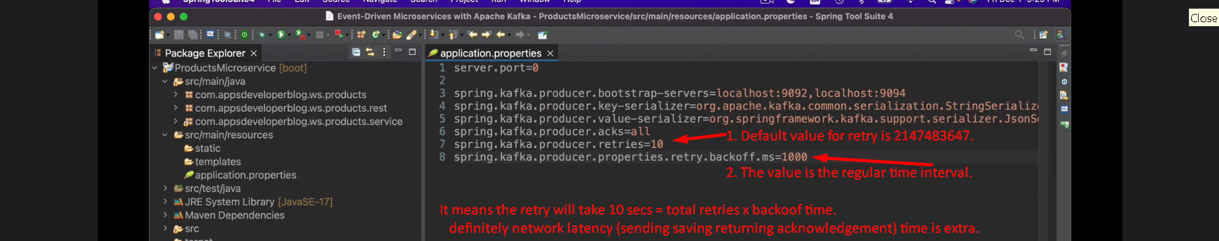
3. 
4. Msg was delivered.   
   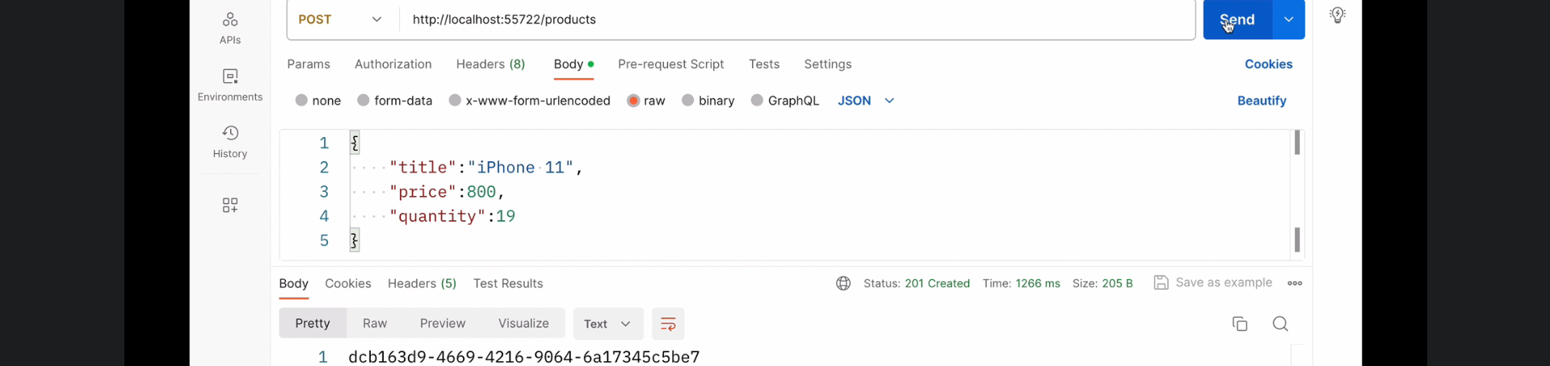
5. 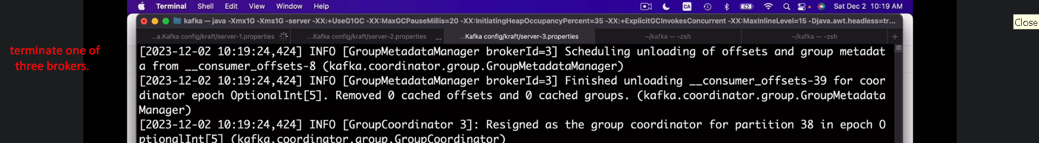
6. 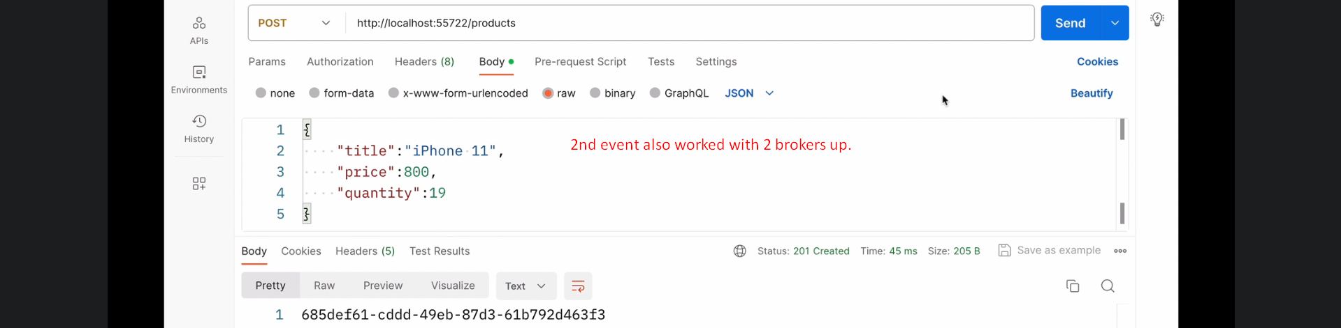
7. 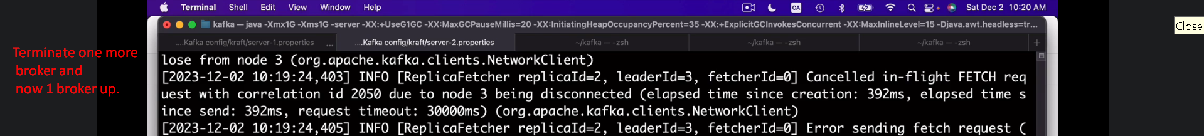
8. 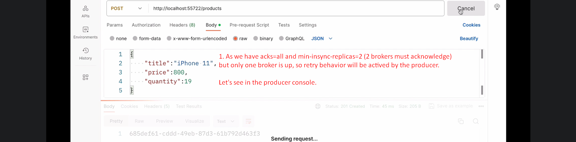
9. 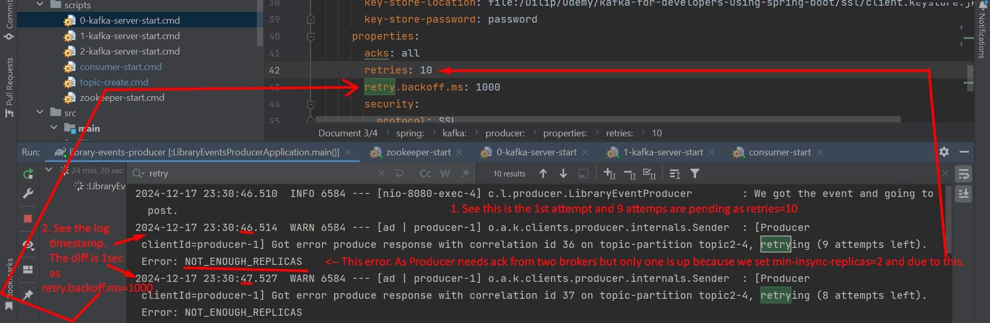
10. 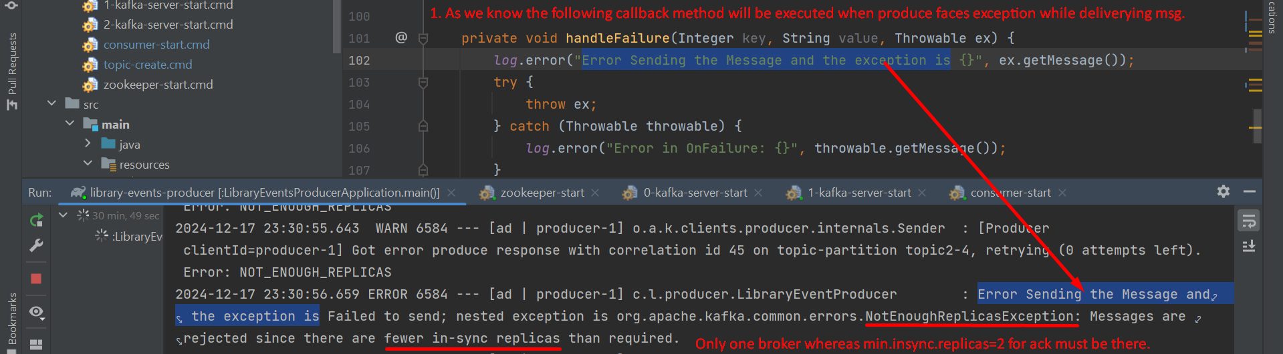
11. Jatin:  
    